Experiment No. 1.4

# Student Name: SUMIT KUMAR UID: 20BCS8226

**Branch: CSE Section/Group: 808 A**

**Semester:** **5 Subject Code: CSP-314 Subject Name: Competitive Coding Lab**

## AIM:

HackerLand National Bank has a simple policy for warning clients about possible fraudulent account activity. If the amount spent by a client on a particular day is greater than or equal to the client's median spending for a trailing number of days, they send the client a notification about potential fraud. The bank doesn't send the client any notifications until they have at least that trailing number of prior days' transaction data. Given the number of trailing days and a client's total daily expenditures for a period of days, determine the number of times the client will receive a notification over all days.

# Code:

#include <bits/stdc++.h> using namespace std;

long long median(long long count[], long long d){

long long countfreq[201]; for(long long i = 0; i < 201; i++){

countfreq[i] = count[i];

}

for(long long i = 1; i < 201; i++){ countfreq[i]+=countfreq[i-1];

}

if(d % 2 == 0){

long long a, b;

for(long long i = 0; i < 201; i++){ if(countfreq[i] >= (d/2)+1){

a = i; break;

}

}

for(long long i = 0; i < 201; i++){ if(countfreq[i] >= (d/2)){

b = i;



break;

}

}

return a+b;

}

else{ //else median is = a*2; for(long long i = 0; i < 201; i++){

if(countfreq[i] >= (d/2)+1){ return i*2;

}

}

}

return -1;

}

int main(){

long long n, d, b, ans = 0, count[201]; cin >> n >> d;

vector<long long> e;

for(long long i = 0; i < n; i++){ long long b;

cin >> b; e.push_back(b);

}

for(long long i = 0; i < 201; i++){ count[i] = 0;

}

for(long long i = 0; i < d; i++){ count[e[i]]++;

}



for(long long i = d; i < n; i++){ ans+=(e[i]>=median(count,d));

count[e[i-d]]--; count[e[i]]++;

}

cout << ans; return 0;

}

**OUTPUT :**



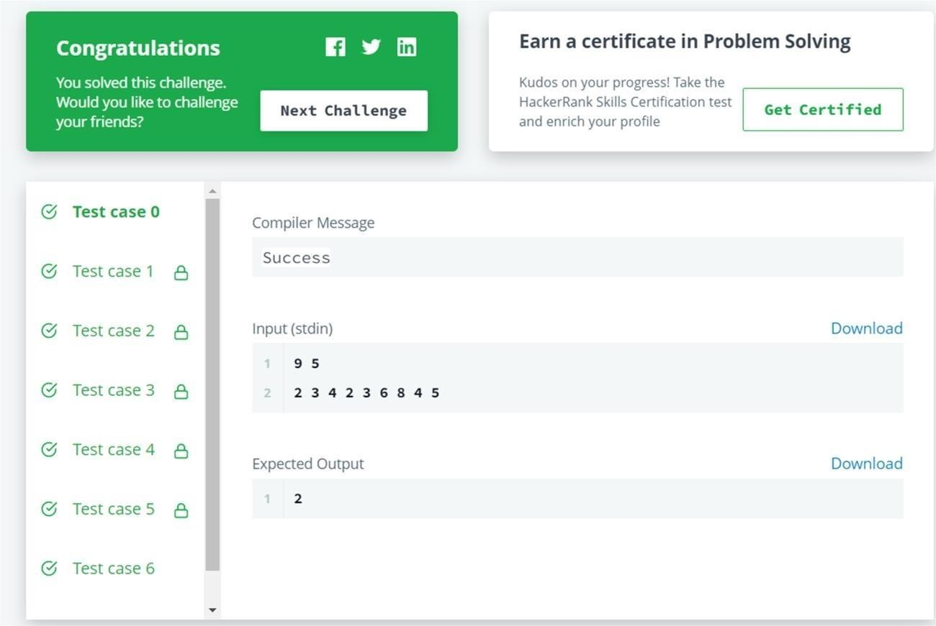

**Question-2**

**Aim:**

Given two arrays of integers, find which elements in the second array are missing from the first array.



# Code:

#include <bits/stdc++.h>using namespace std;

int main() {

long long n,m,temp; cin>>n; vector<int> a; for(long long i=0;i<n;i++) {

cin >> temp; a.push_back(temp);

}

cin>>m; vector<int> b;

for(long long i=0;i<m;i++){cin >> temp; b.push_back(temp);

}

sort(a.begin(),a.end());

sort(b.begin(),b.end());long long i=0,j=0; while(i<n && j<m){

if(a[i]==b[j]) {

i++;j++; b[j-1]=0;

}

else if(a[i]>b[j])j++;else i++;

}

set<int> st; for(i=0;i<m;i++) {

if(b[i]!=0) st.insert(b[i]);

}

for(set<int>::iterator it = st.begin();it!=st.end();it++){cout<<*it<<" ";

}

cout<<endl; return 0;

}

**Output:**

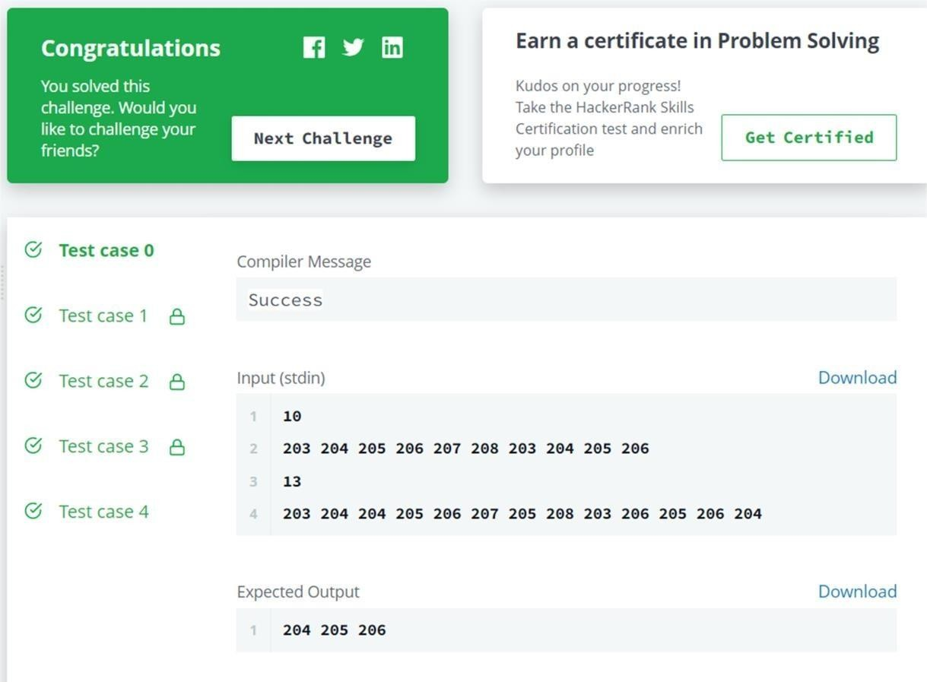

**Learning outcomes (What I have learnt):**

1. Learnt about Vectors.
2. Learnt about searching and sorting techniques.
3. Got an overview of the type of questions on hacker-rank.
4. Get to know about crucial test cases.

**Evaluation Grid (To be created as per the SOP and Assessment guidelines by the faculty):**

|  |  |  |  |
| --- | --- | --- | --- |
| Sr.  No. | Parameters | Marks Obtained | Maximum Marks |
| 1. |  |  |  |
| 2. |  |  |  |
| 3. |  |  |  |